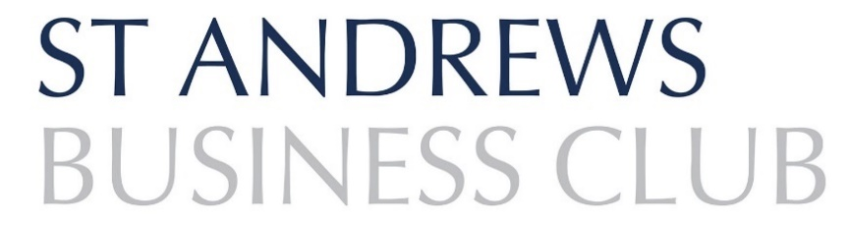

CORPORATE APPLICATION FORM
The aim of the St Andrews Business Club is to further the interests of St Andrews and surrounding area by: -

- The consideration of matters affecting the business and professional interests of the community
- Promoting trade and business within the area
- The promotion of best practice in business
- The interchange of ideas relative to business

Please return completed formS & payment to:

Emma-Jane Kerr, Secretary, St Andrews Business Club,
c/o Thorntons Law LLP, Kinburn Castle, Doubledykes Rd, ST ANDREWS, KY16 9DR.
secretary@standrewsbusinessclub.co.uk

PAYMENT METHODS

BACS: [Details will be supplied when application approved]
Cheque: Made payable to ‘St Andrews Business Club’
Invoice: Please say if you require one.

DETAILS OF APPLICANT 1
Title
First Name
Surname
Job Title
Business Name
Business Address
 |  |  |  |  | Postcode
Business Sector
Telephone
Email
How did you find out about the Club? |  | Social Media |  | Colleague |  |  | Local news
 |  | Web search |  | Current Member |  |  | Other
Applicant 1 Signature
Date
I would like to subscribe to future updates from St Andrews Business Club |  | I do not wish to receive regular updates from St Andrews Business Club

 | Applicant 2 | Applicant 3 | Applicant 4 | Applicant 5
Name
Job Title
Email
Phone
Address (if different to Applicant 1)
Signature
Date
I would like to subscribe to future updates from St Andrews Business Club
I do not wish to receive regular updates from St Andrews Business Club

Our commitment to your privacy

Please note that St Andrews Business Club takes your privacy seriously and will only use your personal information to administer your account and to provide the services you have requested from us.

As part of your Corporate Membership, we require consent for each of your five named members to contact them with details of our upcoming events and follow-up surveys from our networking events.

We look forward to welcoming you all at an event soon!
We look forward to welcoming you at an event soon!

