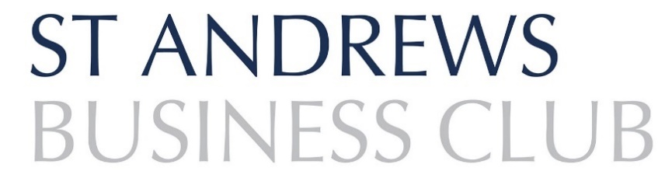

# **INDIVIDUAL APPLICATION FORM**



|  |  |  |  |  |  |  |  |  |  |
| --- | --- | --- | --- | --- | --- | --- | --- | --- | --- |
| Title |  | | | | | | | | |
| First Name |  | | | | | | | | |
| Surname |  | | | | | | | | |
| Business Name |  | | | | | | | | |
| Job Title |  | | | | | | | | |
| Business Address |  | | | | | | | | |
|  | | | | | | | | |
|  | | | Postcode | |  | | | |
| Business Sector |  | | | | | | | | |
| Telephone |  | | | | | | | | |
| Email |  | | | | | | | | |
| Correspondence to: (please tick preferred option) | Business |  | | | Home | | |  | |
| How did you find out about the Club? | Social Media |  | Colleague | | | |  | Local news |  |
| Web search |  | Current Member | | | |  | Other |  |
| **Signature** |  | | | | | | | | |
| **Date** |  | | | | | | | | |

**We look forward to welcoming you at an event soon!**

**Our commitment to your privacy**

St Andrews Business Club takes your privacy seriously and will only use your personal information to administer your account and to provide the services you have requested from us.

To engage with our members, we would like to contact you with details of our upcoming events and follow-up surveys from our networking events.

**I would like to subscribe to future updates from St Andrews Business Club ☐**

**I do not wish to receive regular updates from St Andrews Business Club ☐**

If you consent to us retaining your contact details and liaising with you for this purpose, please tick your preferred methods of contact - **Post** ☐    **Email** ☐    **Telephone** ☐    **Text message** ☐

**PAYMENT METHODS**

**BACS:** [Details will be supplied when application approved]

**Cheque:** Made payable to ‘St Andrews Business Club’

**Invoice:** Please say if you require one.

**Please return completed formS & payment to:**

**Emma-Jane Kerr,**

**Secretary, St Andrews Business Club**

**c/o Thorntons Law LLP,**

**Kinburn Castle,**

**Doubledykes Rd,**

**ST ANDREWS,**

**KY16 9DR**

[**secretary@standrewsbusinessclub.co.uk**](mailto:secretary@standrewsbusinessclub.co.uk)

**The aim of the St Andrews Business Club is to further the interests of St Andrews and surrounding area by: -**

* **The consideration of matters affecting the business and professional interests of the community**
* **Promoting trade and business within the area**
* **The promotion of best practice in business**
* **The interchange of ideas relative to business**